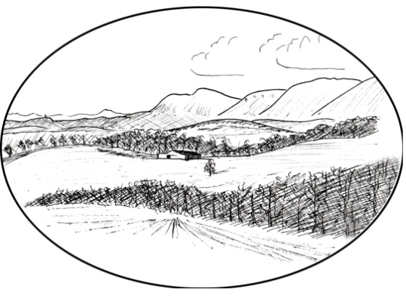
OAKLEY HEALTH CENTRE
WARDLAW WAY
OAKLEY
KY12 9QH

01383 850212

Duty Of Candour Annual Report April 2020 to March 2021

Purpose:
The purpose of this report is to detail any incidents where there has been an unintended or unexpected incident that results in death or harm (or additional treatment is required due to injury that would result in death or harm), where Oakley Medical Practices have been responsible.

Outcome:
I can confirm during April 2020 and March 2021 we have had no incidents where Duty of Candour would apply.

Issued: Jen Walls
Position: Practice Manager & Associate Partner
Date: 21st Sept 2022

